OBJECTIVES:-
1}To evaluate overall performance through total sales, profit, and quantity sold.
2}To analyze sales performance across different product categories.
3}To identify the top 10 customers contributing the highest sales revenue.
4}To analyze monthly sales patterns and trends over time.
5}To evaluate profit performance across different regions.
6}To identify the top 5 products contributing to the highest losses.
7}To analyze the average discount offered across different customer segments.
8}To assess sales performance across different states.
9}To measure order processing efficiency by analyzing shipping delays.
10}To evaluate profitability across product categories using profit margin.
11}To identify customers with multiple purchases and assess repeat buying behavior.
12}To determine the day with the highest sales performance.
13}To evaluate sales and profitability across product sub-categories.
14}To analyze the impact of discounts on overall profit.
15}To track cumulative sales over time to analyze overall sales growth.

1} USE superstore_sales;
SELECT * FROM [cleaning superstore];
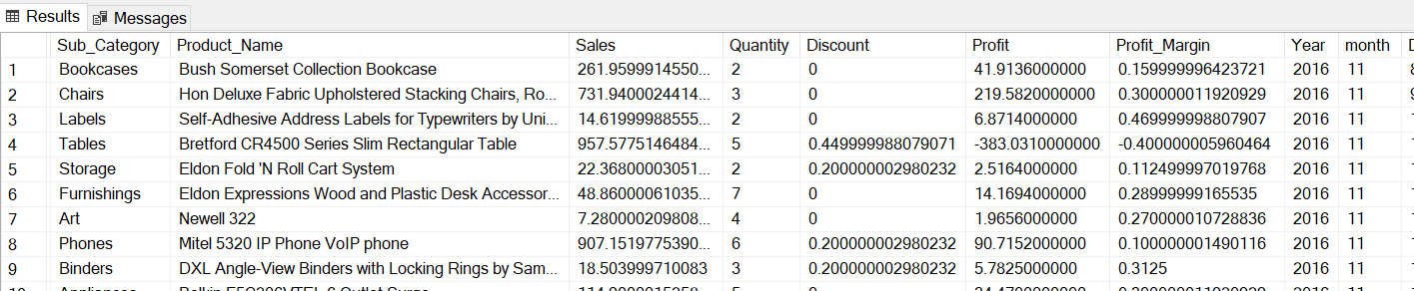
2}alter table cleaning_superstore
alter column Sales Decimal(10,2);
alter table cleaning_superstore
alter column Discount Decimal(10,2);
alter table cleaning_superstore
alter column Profit Decimal(10,2);
alter table cleaning_superstore
alter column Profit_Margin Decimal(10,2);
select * from [cleaning superstore];
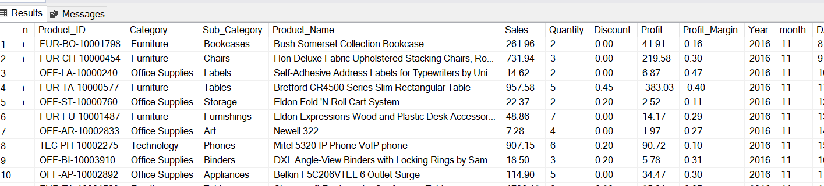

- Total Sales, Profit, and Quantity
SELECT
SUM(Sales) AS total_sales,
SUM(Profit) AS total_profit,
SUM(Quantity) AS total_quantity
FROM [cleaning superstore];
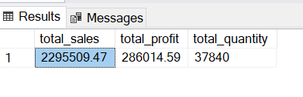
- Sales by Category
SELECT
Category,
SUM(Sales) AS total_sales
FROM [cleaning superstore]
GROUP BY Category
ORDER BY total_sales DESC;
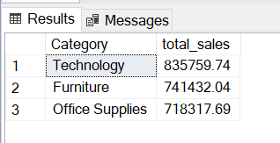
- Top 10 Customers by Sales
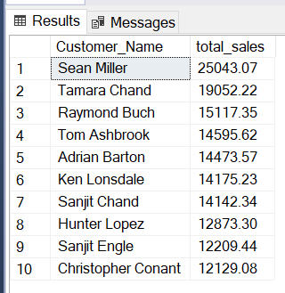

- Monthly Sales Trend
SELECT
Year,
Month,
SUM(Sales) AS monthly_sales
FROM [cleaning superstore]
GROUP BY Year, Month
ORDER BY Year, Month;
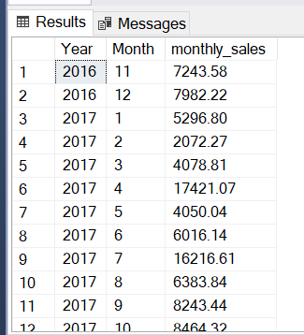

5. Profit by Region
SELECT
Region,
SUM(Profit) AS total_profit
FROM [cleaning superstore]
GROUP BY Region
ORDER BY total_profit DESC;
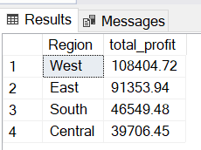

6. Top 5 Loss-Making Products
SELECT Top 5
Product_Name,
SUM(Profit) AS total_profit
FROM [cleaning superstore]
GROUP BY Product_Name
ORDER BY total_profit ASC;
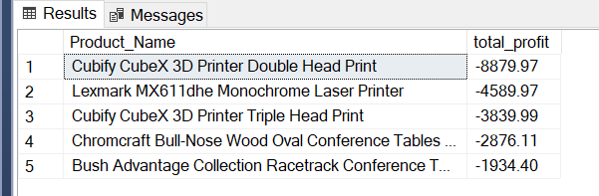

7. Average Discount by Segment
SELECT
Segment,
AVG(Discount) AS avg_discount
FROM [cleaning superstore]
GROUP BY Segment;
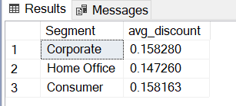

8. Sales by State
SELECT
State,
SUM(Sales) AS total_sales
FROM [cleaning superstore]
GROUP BY State
ORDER BY total_sales DESC;
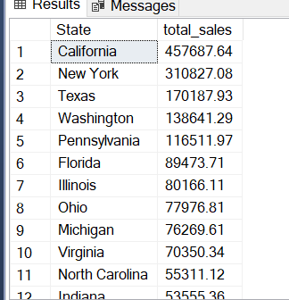

9. Order Processing Time (Shipping Delay)
SELECT
Order_ID,
DATEDIFF(day, Order_Date,Ship_Date) AS shipping_days
FROM [cleaning superstore];
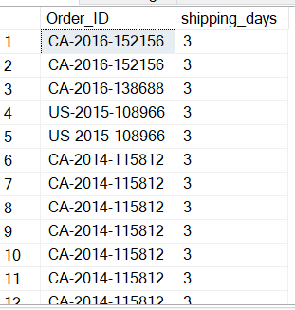
10. Profit Margin by Category
SELECT
Category,
SUM(Profit) / SUM(Sales) AS profit_margin
FROM [cleaning superstore]
GROUP BY Category;
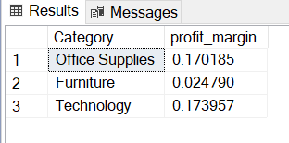
11. Repeat Customers
SELECT
Customer_ID,
COUNT(DISTINCT Order_ID) AS order_count
FROM [cleaning superstore]
GROUP BY Customer_ID
HAVING COUNT(DISTINCT Order_ID) > 1;
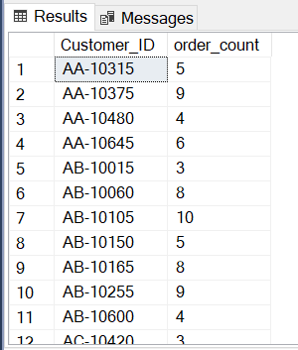
12. Highest Sales Day
SELECT TOP 1
Order_Date,
SUM(Sales) AS total_sales
FROM [cleaning superstore]
GROUP BY Order_Date
ORDER BY total_sales DESC;
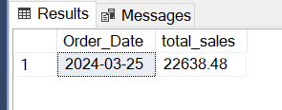
13. Sub-Category Performance
SELECT
Sub_Category,
SUM(Sales) AS total_sales,
SUM(Profit) AS total_profit
FROM [cleaning superstore]
GROUP BY Sub_Category
ORDER BY total_sales DESC;
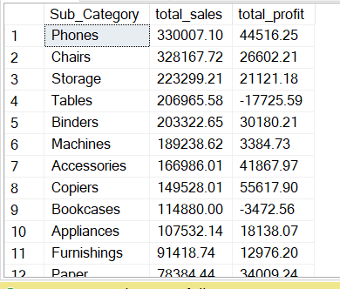
14. Discount Impact on Profit
SELECT
Discount,
AVG(Profit) AS avg_profit
FROM [cleaning superstore]
GROUP BY Discount
ORDER BY Discount;
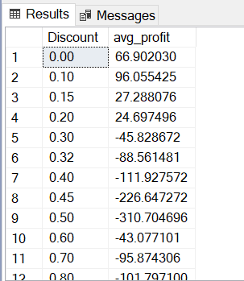
15. Running Total of Sales
SELECT
Order_Date,
SUM(Sales) OVER (ORDER BY Order_Date) AS running_sales
FROM [cleaning superstore];
